Heat Exchanger Proposal
Ashwin Narayanan, Sichen Deng, Eva Zhao, Amy Tang, Brendan Glennon

Description
The proposed device consists of a compact shell-and-tube heat exchanger and a bundle of parallel copper tubes. Hot water flows through the tubes, while cold water flows through the surrounding shell cavity. External connections are configured to enable concurrent or counterflow by reversing them during testing.

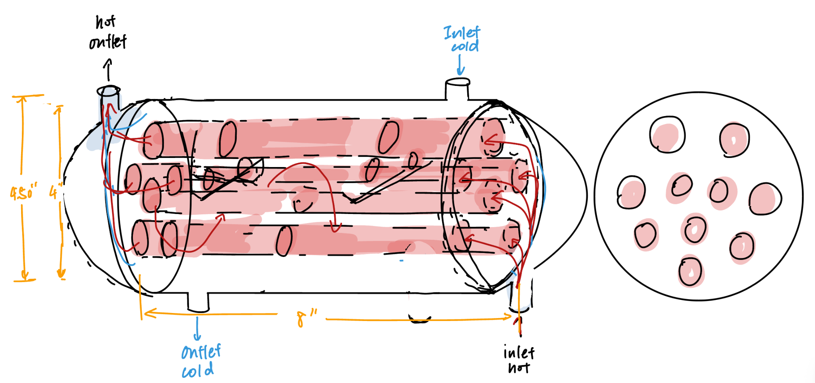

Exterior
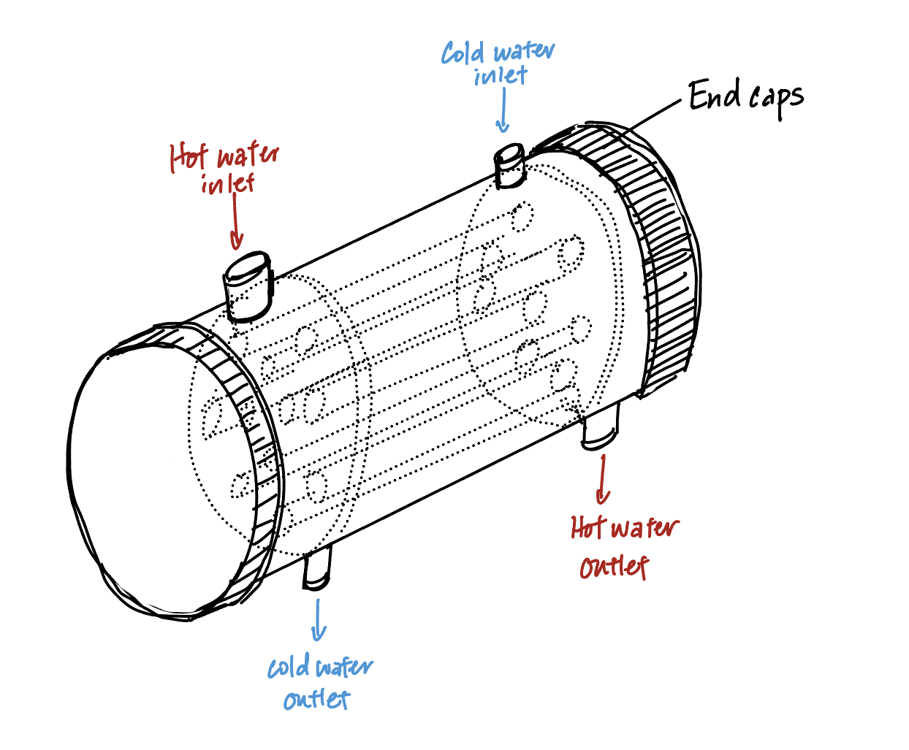
The heat exchanger has four union couplings located on the exterior of the PVC casing. It is connected to the Armfield rig through these couplings. The hot inlet, hot outlet, cold inlet, and cold outlet positions are labeled in the exterior drawing above. Each will be connected to the corresponding provided union coupling. This coupling will ensure a leak-tight connection and clearly specify the boundary conditions for the hot and cold fluid inlets and outlets during testing.

Components:
PVC shell
End caps (x2)
Four union coupled ports (Hot_in, Hot_out, Cold_in, Cold_out)

Interior
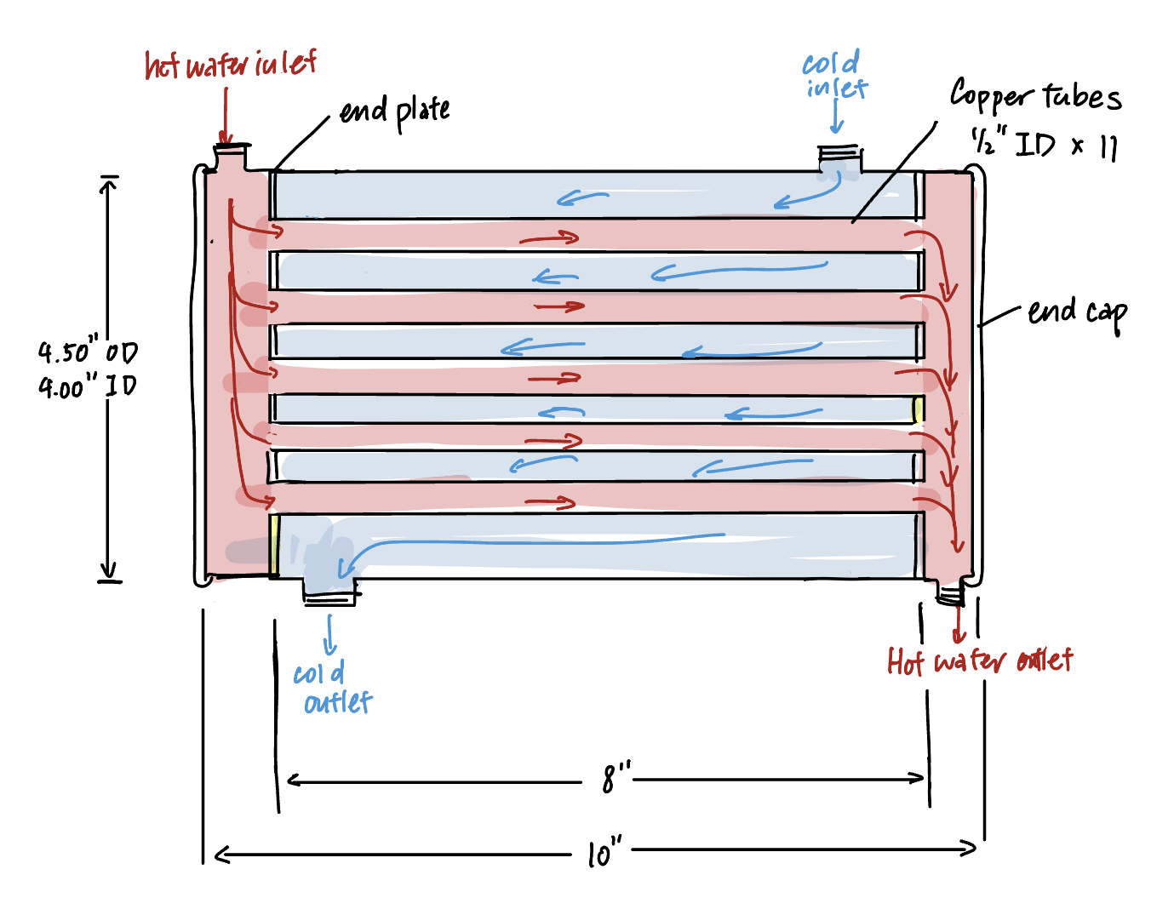
Inside the shell-and-tube heat exchanger with a PVC casing, there are 11 parallel copper tubes along the length of the exchanger, fixed to two side end plates. The hot water enters the tubes at the hot inlet, flows through the 11 tubes, and then exits at the hot outlet, while the cold water (flowing in the opposite direction to the hot water) enters the shell cavity, flows through the space between the tubes, and then exits at the cold outlet.

Components:
PVC casing
Copper tubes (×11)
End plates
End caps

Tube Plate
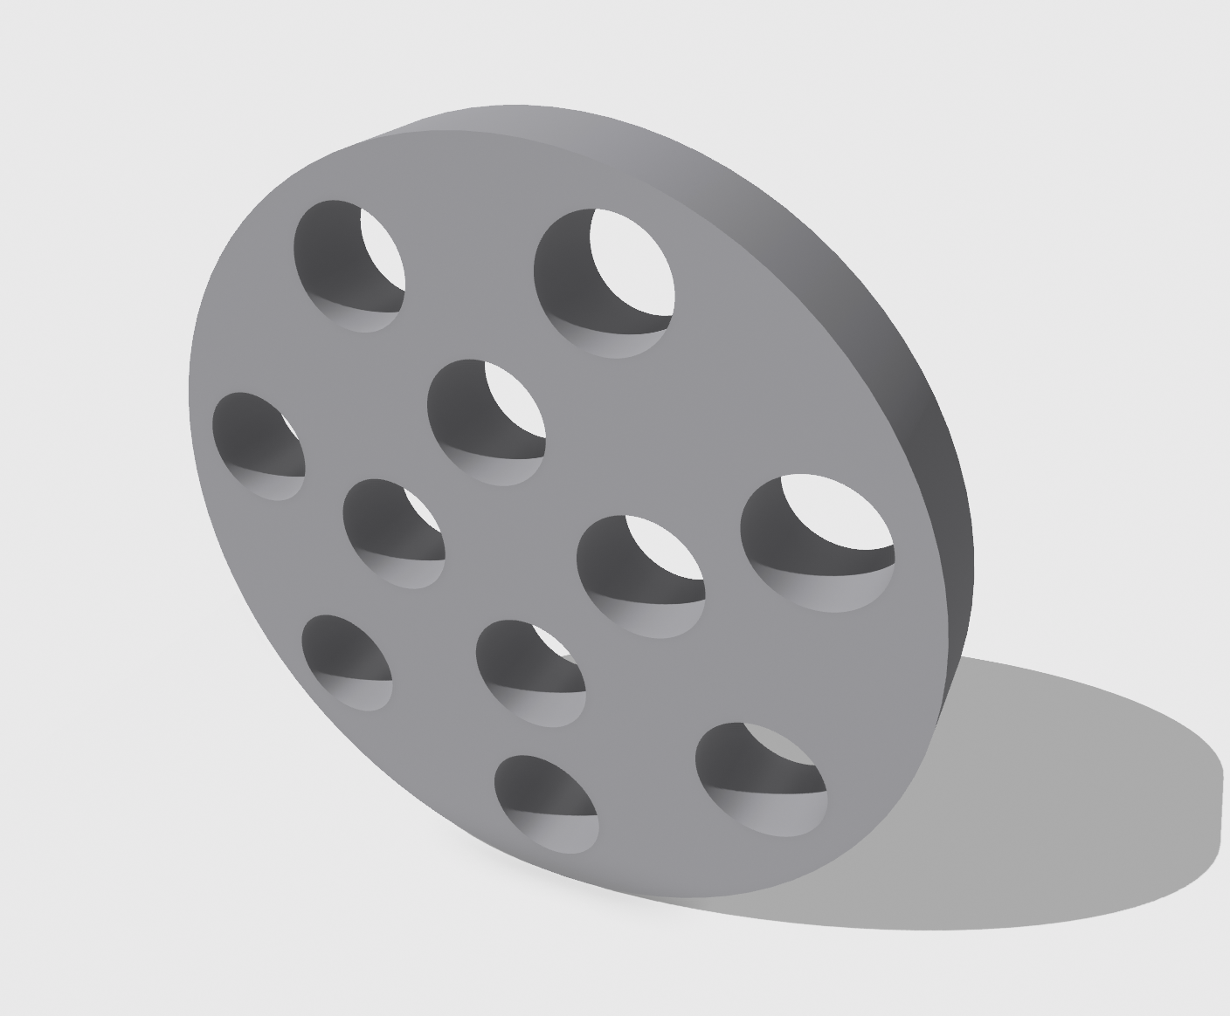
Isometric View


Front View

Materials and Components

Component/Material | Link | Unit Cost | Quantity | Total Cost
Copper Tube Coil (½’’ ID, ⅝” OD, 10’ length) | Home Depot | $39.96 | 1 | $39.96
End Caps (4 ½’’ ID) | Amazon | $14.79 (pack of 2) | 1 | $14.79
PVC Pipe (4’’ ID, 4.5” OD) | Home Depot | $20.86 | 1 | $20.86
Acrylic Sheet (12”x6”) | McMaster | $11.79 | 1 | $11.79
Glue | Amazon | $6.54 | 1 | $6.54
Total Cost | $93.94

Fabrication
- Cut out circular plate shape from acrylic sheet using laser cutter with eleven holes throughout for pipes to go through (repeat process for second plate)
- Use pipe cutter to separate copper pipe into 8” segments
- Use metal glue to attach each pipe to respective hole in acrylic sheet
- Use bandsaw to cut PVC pipe into three sections
- Attach and seal acrylic plates into two gaps, joining the PVC back together (see image below)
- Place and tighten end caps on both ends of the PVC
- Use drill/drill press to cut four holes in PVC for cold and hot water inlets/outlets
- Insert provided pipe nipples into four holes - tighten and seal
- Attach four union connectors to pipe nipples and seal

Fabrication Plan 2.0

Comparison to Armfield Exchanger
The Armfield HT31 used in the laboratory employs a concentric tube-in-tube configuration, where heat transfer occurs across a single cylindrical interface between an inner stainless-steel tube and the surrounding annular cold-water region. While mechanically simple and well suited for instructional purposes, this arrangement is fundamentally limited by its available heat transfer surface area, restricted to a single primary interface within a fixed bounding volume.
With both hot and cold flow rates fixed at 2 L/min, the only practical route to improved thermal performance is increasing the overall heat transfer conductance, UA. Our proposed multi-tube shell design directly targets this parameter by distributing flow across several smaller-diameter tubes arranged in parallel within a cylindrical shell. This increases the total wetted surface area substantially while remaining within the same spatial envelope, exploiting the geometric advantage that a bundle of small tubes offers far greater surface-area-to-volume ratio than a single large tube.
Since the rate of heat transfer is governed by $q=UA×ΔT_{lm}$, and the mean temperature difference is dictated by the fixed inlet conditions, maximising A becomes the dominant design lever. The increased wetted perimeter of the tube bundle also promotes more effective use of the internal volume compared to the single-tube Armfield baseline, even in the absence of shell-side baffles.
Geometric optimisation is therefore the central design strategy. The configuration is intentionally sized to maximise internal surface area within the allowable constraints, with the direct objective of increasing UA and thereby improving the primary Figure of Merit, F1, defined as the rate of heat removed from the hot stream. Although pressure drop and fabrication complexity must be managed carefully, the multi-tube arrangement is expected to deliver meaningfully greater overall heat transfer capacity than the Armfield concentric exchanger under identical operating conditions.

Questions
- How do manufacturing costs work? (bandsaw, drill press, etc.)
- Can we share orders/costs with other groups?
- Will any starter/sample Python code be posted?

Feedback from Critique
- Could look into Bulkhead fittings
- Baffles
- Have some Reynolds number calculation
- Have some friction factor calculations
- Have some pressure drop calculation
- It’s hard to solder different metals

- Shell-side baffle or flow director included to prevent short circuiting
- How will uniform flow distribution be ensured across all 11 parallel tubes?
- A quantitative pressure drop estimate would help evaluate structural integrity, esp if adhesive bonding is used
- Basic equipment is free (bandsaw, drill press, etc)
- Can share orders/costs with other groups
- Sample Python code is on canvas
  - Matlab code also on Canvas (they’re not the same code)

